Title: Customer Segmentation using K-Means Clustering

Introduction
This project focuses on customer segmentation using the K-Means clustering algorithm. Customer segmentation helps businesses understand different customer groups based on their behavior and demographics, allowing for better marketing strategies and personalized services.

2️⃣ Objective
The objective of this task is to:
- Segment customers based on income and spending behavior.
- Identify distinct customer groups using unsupervised machine learning.
- Visualize and interpret the clusters.

3️⃣ Dataset Description
The dataset used is the Mall Customer Segmentation Dataset from Kaggle. It contains the following columns:
- CustomerID
- Gender
- Age
- Annual Income (k$)
- Spending Score (1–100)
For clustering, the features Annual Income and Spending Score were selected.

4️⃣ Tools & Technologies Used
- Python
- Scikit-learn
- Pandas
- Matplotlib & Seaborn

⃣5️ Methodology

Step 1: Data Loading
The dataset was loaded using Pandas and basic inspection was performed.

Step 2: Data Preprocessing
- Removed the CustomerID column.
- Selected relevant features.
- Applied StandardScaler to normalize the data.

Step 3: Finding Optimal K
The Elbow Method was used by plotting inertia values for different K values. The optimal number of clusters was found to be K = 5.
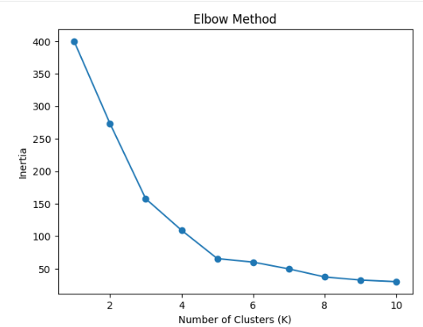

Step 4: Model Training
K-Means clustering was applied with K = 5.

Step 5: Visualization
Clusters were visualized using a scatter plot with different colors representing each customer segment.
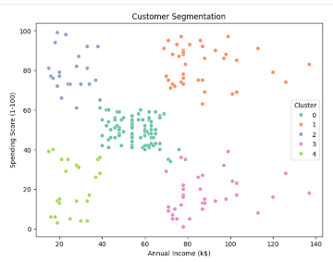

6️⃣ Results & Interpretation
The model segmented customers into 5 distinct groups:
Cluster | Description
0 | Low income, low spending – Budget customers
1 | High income, high spending – Premium customers
2 | High income, low spending – Careful customers
3 | Low income, high spending – Impulsive buyers
4 | متوسط income & spending – Average customers
These insights help businesses target customers more effectively.

7️⃣ Conclusion
K-Means clustering successfully segmented customers into meaningful groups. This segmentation can be used for personalized marketing, customer retention strategies, and improving customer experience.

8️⃣ Deliverables
- Elbow plot
- Cluster visualization
- Segmented dataset (CSV file)

